1. A catering company prepared and served 300 meals at an anniversary celebration last week using
eight workers. The week before, six workers prepared and served 240 meals at a wedding reception.
a. For which event was the labor productivity higher? Explain.
b. What are some possible reasons for the productivity differences?

Answer
Given
Last week: Output = 300 meals, Workers = 8
Week before: Output = 240 meals, Workers = 6

Formula:
$$\text{Labor Productivity}=\frac{\text{Meals served}}{\text{Number of workers}}$$

Last week:
$$\frac{300}{8}=37.5\text{ meals per worker}$$

Week before:
$$\frac{240}{6}=40\text{ meals per worker}$$

Answer (a)
Last week productivity = 37.5 meals/worker and Week before productivity = 40 meals/worker
So, the week before had higher labor productivity.

Answer (b)
Some possible reasons:
- Different type of event
- Different menu complexity
- Different service setup
- Different worker skill level
- More waiting or coordination problems with larger crew
- Different location or equipment
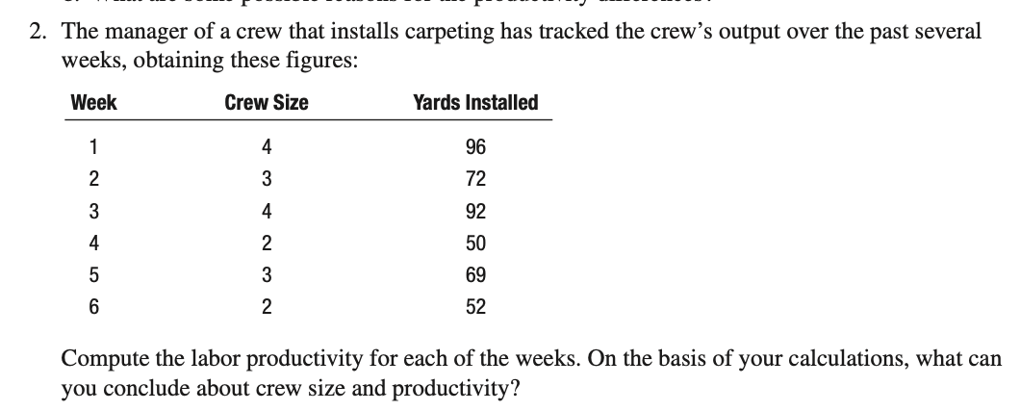
Answer

Given table
Week | Crew Size | Yards Installed
1 | 4 | 96
2 | 3 | 72
3 | 4 | 92
4 | 2 | 50
5 | 3 | 69
6 | 2 | 52

Formula
$$\text{Labor Productivity}=\frac{\text{Yards installed}}{\text{Crew size}}$$

For Week 1:
$$\frac{96}{4}=24$$For Week 2:
$$\frac{72}{3}=24$$For Week 3:
$$\frac{92}{4}=23$$For Week 4:
$$\frac{50}{2}=25$$For Week 5:
$$\frac{69}{3}=23$$For Week 6:
$$\frac{52}{2}=26$$
Week | Productivity (yards per worker)
1 | 24
2 | 24
3 | 23
4 | 25
5 | 23
6 | 26

Smaller crews show higher productivity (25–26) compared to larger crews (23–24). Therefore, as crew size decreases, productivity per worker increases due to better efficiency and coordination.
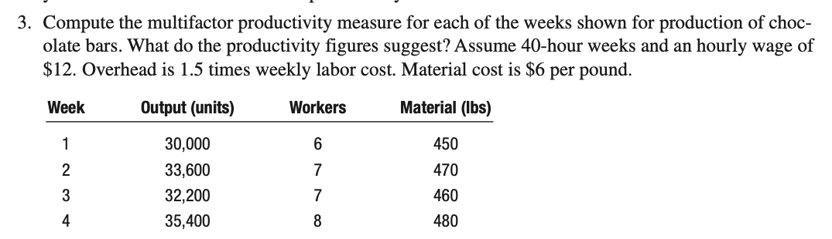

Answer:

Given
- 40-hour week
- Wage = $12/hour
- Overhead = 1.5 × weekly labor cost
- Material cost = $6/lb

Formula
$$\text{MFP}=\frac{\text{Output}}{\text{Labor cost + Material cost + Overhead}}$$

For Week 1
Output = 30,000
Workers = 6
Material = 450 lbs

Labor cost:
$$6×40×12=2880$$Material cost:
$$450×6=2700$$Overhead:
$$1.5×2880=4320$$Total input cost:
$$2880+2700+4320=9900$$MFP:
$$\frac{30000}{9900}=3.03$$

For Week 2
Output = 33,600
Workers = 7
Material = 470 lbs
$$Laborcost=7×40×12=3360$$
$$Material cost= 470×6=2820$$

$$Overhead=1.5×3360=5040$$
$$Total input cost=3360+2820+5040=11220$$
$$MFP=\frac{33600}{11220}=2.99$$

For Week 3
Output = 32,200
Workers = 7
Material = 460 lbs
$$Labor cost=7×40×12=3360$$
$$Material cost=460×6=2760$$
$$Overhead=1.5×3360=5040$$
$$Total input cost=3360+2760+5040=11160$$
$$MFP=\frac{32200}{11160}=2.89$$

For Week 4
Output = 35,400
Workers = 8
Material = 480 lbs

Labor cost:
$$8×40×12=3840$$Material cost:
$$480×6=2880$$Overhead:
$$1.5×3840=5760$$

Total input cost:
$$3840+2880+5760=12480$$

MFP:

$$\frac{35400}{12480}=2.84$$The productivity figures suggest that multifactor productivity is gradually decreasing from Week 1 to Week 4.

4. A company that makes shopping carts for supermarkets and other stores recently purchased some
new equipment that reduces the labor content of the jobs needed to produce the shopping carts.
Prior to buying the new equipment, the company used five workers, who produced an average of
80 carts per hour. Workers receive $10 per hour, and machine cost was $40 per hour. With the new
equipment, it was possible to transfer one of the workers to another department, and equipment cost
increased by $10 per hour while output increased by four carts per hour.
a. Compute labor productivity under each system. Use carts per worker per hour as the measure of
labor productivity.
b. Compute the multifactor productivity under each system. Use carts per dollar cost (labor plus
equipment) as the measure.
c. Comment on the changes in productivity according to the two measures, and on which one you
believe is the more pertinent for this situation.

Answer:

(a) Answer:

Formula
$$\text{Labor Productivity}=\frac{\text{Carts per hour}}{\text{Number of workers}}$$Old system
$$\frac{80}{5}=16$$New system
$$\frac{84}{4}=21$$
Old labor productivity = 16 carts per worker per hour and New labor productivity = 21 carts per worker per hour

(b) Answer:

Formula
$$\text{MFP}=\frac{\text{Output}}{\text{Labor cost + Equipment cost}}$$Old system
Labor cost:
$$5×10=50$$Total cost:
$$50+40=90$$MFP:
$$\frac{80}{90}=0.89$$New system
Labor cost:
$$4×10=40$$Total cost:
$$40+50=90$$MFP:
$$\frac{84}{90}=0.93$$Old MFP = 0.89 carts per dollar and New MFP = 0.93 carts per dollar

(c) Answer:
Both measures show improvement:
- Labor productivity increased from 16 to 21
- Multifactor productivity increased from 0.89 to 0.93
The multifactor productivity measure is more pertinent because it includes both labor and equipment cost.

5. An operation has a 10 percent scrap rate. As a result, 72 pieces per hour are produced. What is the
potential increase in labor productivity that could be achieved by eliminating the scrap?

5) Answer:

Given
- Scrap rate = 10%
- Actual good output = 72 pieces/hour
If scrap is 10%, then 72 pieces/hour is only 90% of potential output.

Step 1: Find potential output with no scrap
$$\text{Potential output}=\frac{72}{0.90}=80$$Step 2: Increase in productivity
$$80-72=8$$Step 3: Percent increase
$$\frac{8}{72}×100=11.11\%$$
The potential increase in labor productivity is:
$$\boxed{11.11\%}$$

6. A manager checked production records and found that a worker produced 160 units while working
40 hours. In the previous week, the same worker produced 138 units while working 36 hours. Did
the worker’s productivity increase, decrease, or remain the same? Explain.

6) Answer

Given
Current week: Output = 160 units, Hours = 40
Previous week: Output = 138 units, Hours = 36

Formula
$$\text{Productivity}=\frac{\text{Units produced}}{\text{Hours worked}}$$Current week:
$$\frac{160}{40}=4$$Previous week:
$$\frac{138}{36}=3.83$$
Current week = 4.00 units/hour and Previous week = 3.83 units/hour
The worker’s productivity increased.

